Lab 2 Javascript Frameworks

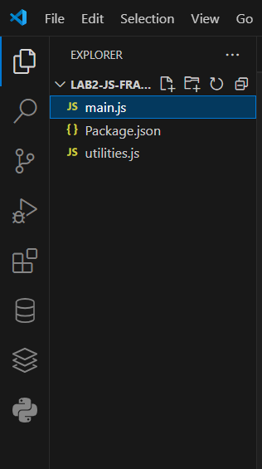This is the Folder structure for the LAB 2

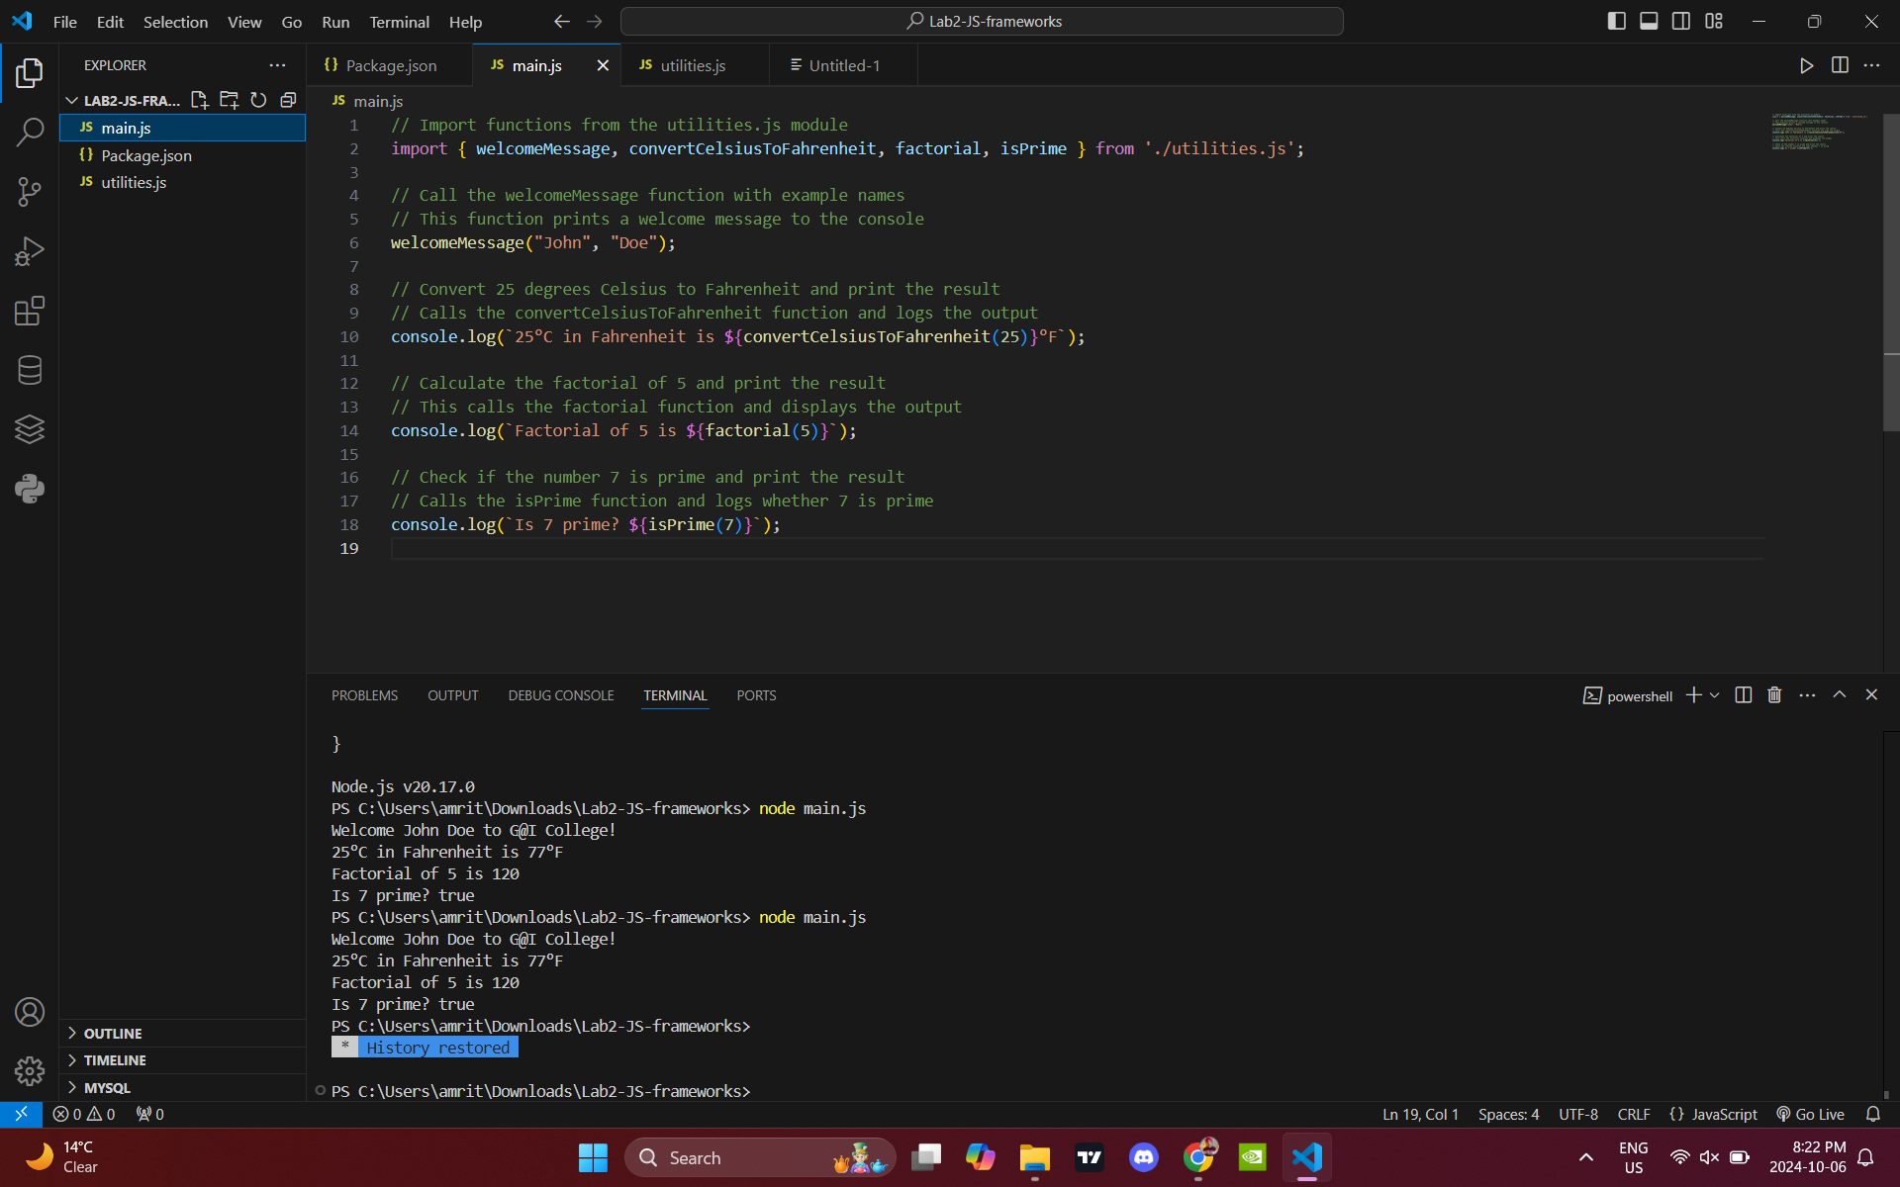This is the Code and Terminal window with the output of the code.